Climate Science Discussion

Tony Noerpel

After publishing Joe LaFiandra’s opinion piece on climate change in the December issue, the publishers and editors asked me to write an article conveying the view of the scientific community in rebuttal, which was published in January, but to do it in only 900 words placing the opinion of two industry lobbyists (LaFiandra’s references) on the same footing as the entire scientific community. The amount of verifiable information is wildly asymmetric between denial of climate change (essentially none) and the scientific consensus (100,000+ peer-reviewed papers). Many well-intentioned people believe we can have a frank debate regards the pros and cons but Mark Twain observed that if one argues with a fool, onlookers cannot tell the difference. When LaFiandra claims, for example and without attribution, that climate models are wrong and he trusts paleoclimatology, he is being foolish. If I were to argue without attribution that the models are skillful and paleoclimatological estimates are in any case even more frightening than the model results that too would be foolish, which is why I included references to the peer-reviewed science in my rebuttal. We do not need a debate but a clear understanding of what the science actually says.

To be frank, most contrarian arguments against the IPCC conclusions are silly and a few are downright dishonest. Lost within this noise are a few very good skeptical criticisms which deserve our attention. Unfortunately, discussions with contrarians are mostly a stream of easily debunked arguments. The Inhofe alibi that only God can change the climate is an example. If we carry it to its logical conclusion, a person can kill another person and plead that only God can take a life. But God seems to have set no limits on our misbehavior. One of LaFiandra’s references, CATO lobbyist Pat Michaels has confirmed at a Heartland Institute gathering [Michaels] that “Global warming is real and the warming in the second half of the twentieth century, people had something to do with it,” clearly contradicting Inhofe.

Another irrational argument is due to Republican strategist Frank Luntz [Luntz], who argued “first they called it climate change then they called it global warming.” Besides not being true, what the heck difference does it make to the science whether we call it continental drift or plate tectonics? Since we know the source and know the motivation, we know this one is dishonest in addition to being wrong. Luntz believes people are motivated by emotion rather than reason. He believes this is a good thing, certainly for him in his line of work. I think it is creepy but it is not science.

Yet another foolish argument is “we breath out carbon dioxide.” Plants photosynthesize carbon dioxide out of the atmosphere and all of life returns it via respiration. It is a closed loop. The carbon dioxide exhausted by a power plant comes from the lithosphere, where it had been locked up for perhaps a hundred million years. If a media pundit like George Will or Tucker Carlson uses this argument, we can write it off as a consequence of scientific illiteracy, but if a physicist uses it, we can hardly avoid concluding that dishonesty is in play.

The problem we all have is how do we extract the signal, the truly important skeptical concerns with the IPCC conclusions from the noise, the proliferation of denialist nonsense? This is especially important for the media which has an ethical obligation to at least try to tell the truth.

The Heartland Institute, an industry lobbying organization, proposed “teaching the controversy” as a way to teach climate physics in our schools. This is not a good idea, by the way, because this institute was founded to lobby on behalf of tobacco companies and convey to the public the benefits of second-hand tobacco smoke. When it became more profitable to lobby for the fossil fuels industry, they transitioned to denying climate change. William Happer works for them, apparently pro bono, as a lobbyist. However, Happer had a distinguished career as a physicist in academia before retiring and was recently a climate advisor to President Trump. In December 2019, he gave a talk on climate change in Madrid, Spain [Happer] coincident, but not associated, with the COP25 conference on climate change. We can assume Happer is more knowledgeable than politicians, and media pundits on the subject of climate change and if there are any substantive, skeptical objections to the IPCC reports, we can expect Happer to be aware of them and present a credible and verifiable case. By considering his talk, we can hopefully identify any real and significant objection to the scientific consensus on human-caused climate change and avoid getting bogged down in foolishness.

The ecologist Garrett Hardin wrote in his book “Filters against Folly: How to Survive Despite Economists, Ecologists, and the Merely Eloquent” that we are all literate and while we pride ourselves on the evolutionary development of complex language, we use words both to convey useful information and to deceive each other by for example playing on emotions. His first filter against such folly is numeracy, i.e., look for the numbers, and his second filter is ecolacy. Ecolacy means step back and take in the whole picture. The numbers identify the meat in a lecture but numbers can be deceptively selected. We need to ask what the speaker might be leaving out, i.e., the context or the bigger picture.

In his talk, Happer spends a lot of time quoting dead people. We all do this. It can liven up a dull discussion but rarely conveys much information. Applying numeracy, we note his first numbers and therefore the start of his scientific argument begins seven minutes into his 29-minute presentation. He compares the output breath of a woman with the output of a power plant as per Table 1 (for which he fails to provide a reference) noting that “our own breath doesn’t differ that much from a power plant exhaust”. Actually, they are quite different. For the woman carbon dioxide is 4% of a tiny number and for a power plant it is 20% of a huge number. But the difference is even more evident when we consider the entirety of the output including for the person, the poop and the pee, which happen to be fertilizer and is readily recycled by nature, and for the power plant the mercury, sulfur dioxide, particulates, radon and coal ash which are all harmful pollutants. Being a physicist, we can expect him to know the difference with respect to the inputs: air and vegetables for the person and for the power plant, air and materials mined from lithosphere. We can learn something about the Earth’s carbon cycles by considering the whole picture including what Happer is leaving out.

Figure 1 from NASA [NASA] shows that photosynthesis pulls 120 billion tons of carbon as carbon dioxide out of the atmosphere every year while plant and microbial respiration returns 120 billion tons back to the atmosphere every year. The total amount of respiration left for all animals including humans is insignificant to this cycle. Humans are only 0.01% of all biomass on the planet [Bar-On]. Every year some of this carbon leaks out of these surface reservoirs and get sequestered to eventually become fossil fuels. From the figure we see that the total estimated fossil carbon is 10,000 billion tons. The figure also says that we are releasing this carbon at the rate of 9 billion tons per year, but that was in 2011 when the data for this figure originated. It is now about 10 billion tons and still growing. This fossil carbon was sequestered since the Cambrian explosion 542 million years ago and the average annual amount of carbon sequestration is 20,000 tons per year. We are releasing back into the atmosphere 500,000 years’ worth of sequestered carbon every year. It is a little less for coal and natural gas and probably more like a million years’ worth of oil, being rarer. Happer’s argument is unverifiable because he does not have a reference. It is deceitful because he is playing on our emotions, i.e., the comparison to a woman, rather than appealing to our reason. If he had a point, he would compare all of fossil fuel emissions to all of respiration. And in any event his argument does not contradict the IPCC reports.

We will continue the review of the rest of Happer’s arguments next month with the hope of finding an important skeptical argument. For the skeptical mind there are lots of additional interesting details regards the various carbon cycles in the Earth system worth discussing. I’ve only scratched the surface of the organic carbon cycles. There is also a significant exchange of inorganic carbon between various reservoirs on Earth. I recommend four text books for the skeptical mind [Berner], [Kump], [Langmuir] and [Lunine]. The science really is quite interesting.

All wonderful Blue Ridge Leader readers are encouraged to submit contrarian arguments in the comment space or privately. While there are stupid assumptions, there are no stupid questions. It is perfectly reasonable to ask why scientists are concerned about the carbon dioxide from a power plant but not the carbon dioxide from animals, bacteria, fungus and plants. It is stupid to assume this somehow contradicts the IPCC report as if scientists haven’t thought of this.

Table 1 from Happer’s presentation [Happer]
 | Power Plant’s breath | Alice’s breath
Nitrogen | 70% | 75%
Oxygen | 5% | 15%
Water | 5% | 6%
Carbon Dioxide | 20% | 4%

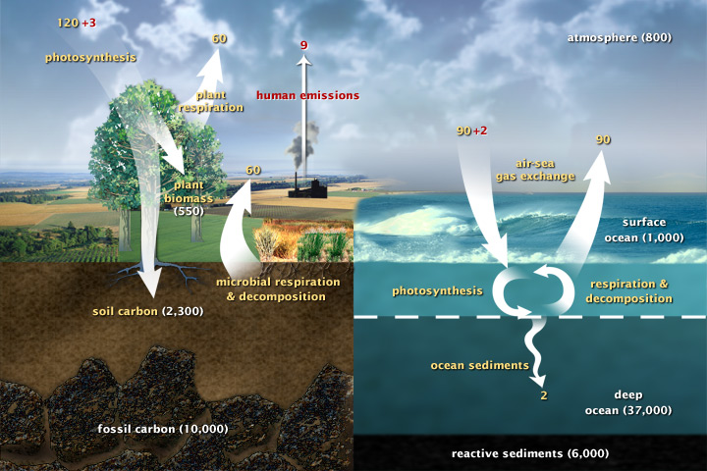
Figure 1. This diagram of the fast carbon cycle shows the movement of carbon between land, atmosphere, and oceans. Yellow numbers are natural fluxes, and red are human contributions in gigatons of carbon per year. White numbers indicate stored carbon. (Diagram adapted from U.S. DOE, Biological and Environmental Research Information System.) Source: [NASA]

[Bar-On] Yinon M. Bar-On, Rob Phillips, and Ron Milo, The biomass distribution on Earth, PNAS, Aril 13, 2018, www.pnas.org/cgi/doi/10.1073/pnas.1711842115

[Berner] Robert Berner, The Phanerozoic Carbon Cycle, Oxford University Press, 2004.

[Happer] https://www.youtube.com/watch?v=j8KxVQFoyT0

[Kump] Lee Kump, James Kasting, Robert Crane, The Earth System, Pearson Prentice Hall, 2004.

[Langmuir] Charles Langmuir and Wally Broecker, How to Build a Habitable Planet, The Story of Earth from the Big Bang to Humankind, Princeton University Press, 2012.

[Lunine] Jonathan Lunine, Earth, Evolution of a Habitable World, Cambridge University Press, 1999.

[Luntz] https://en.wikipedia.org/wiki/Frank_Luntz

[Michaels] http://www.youtube.com/user/greenman3610#p/u/2/QwnrpwctIh4

[NASA] NASA Earth Observatory https://earthobservatory.nasa.gov/features/CarbonCycle

